Ques1: Write a Java program to implement the concept of importing classes from user defined package.

Source Code

**package** UserDefined;

**public** **class** PackageDemo {

**public** **static** **void** main(String args[]) {

System.***out***.println("This is demo package");

}

**public** **void** msg() {

System.***out***.println("Msg method inside PackageDemo");

}

}

**import** UserDefined.PackageDemo;

**public** **class** ImportClass{

**public** **static** **void** main(String args[]){

PackageDemo obj1 = **new** PackageDemo();

obj1.msg();

}

}

Output

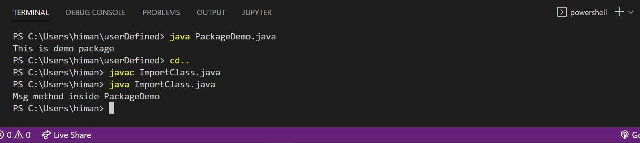

Ques2: Write a program to make a package Balance. This has an Account class with Display_Balance method. Import Balance package in another program to access Display_Balance method of Account class.

Source Code

**package** Balance;

**public** **class** Account {

**static** **int** *balance* = 200;

**static** **public** **void** Display_Balance() {

System.***out***.println("Balance is: "+*balance*);

}

}

**import** Balance.Account;

**public** **class** ImportBalance {

**public** **static** **void** main(String args[]) {

Account obj = **new** Account();

obj.Display_Balance();

}

}

Output

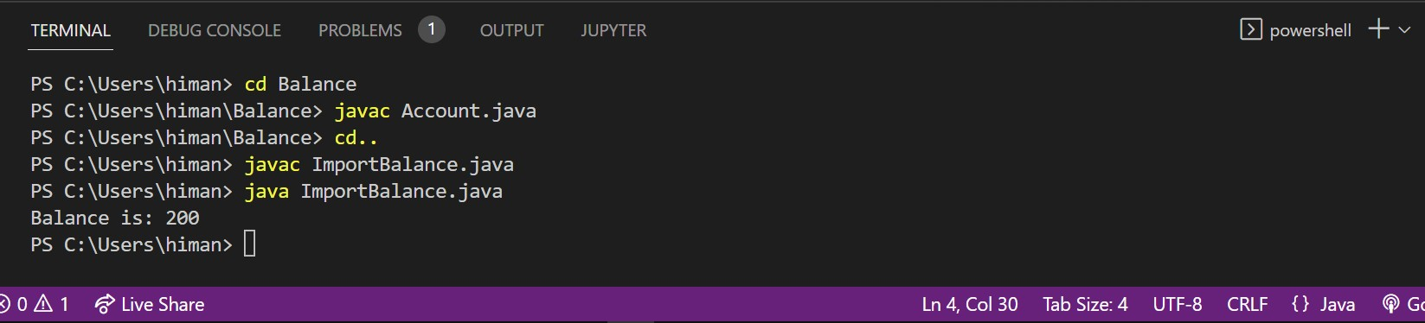

Ques3: WAP to create a package p with class A with 4 types of access protected methods. Show which of these methods can be used in different package’s class i.e. there is main() in class B in package Q and 4 methods are in Class A in package p.

Source Code

**package** p;

**public** **class** A{

**public** **void** meth1(){

System.***out***.println("This is public meth1");

}

**private** **void** meth2(){

System.***out***.println("This is meth2");

}

**void** meth3(){

System.***out***.println("This is meth3");

}

**protected** **void** meth4(){

System.***out***.println("This is meth4");

}

**public** **static** **void** main(String args[]){

A obj = **new** A();

obj.meth1();

}

}

a)

**package** Q;

**import** p.A;

**public** **class** B1{

**public** **static** **void** main(String args[]){

A obj1 = **new** A();

obj1.meth1();

}

}

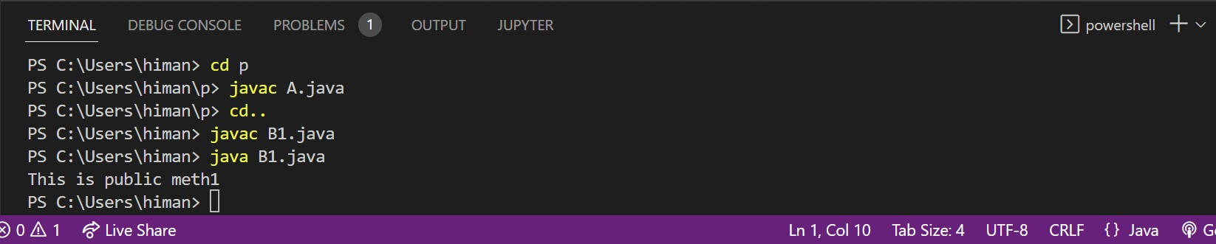Output

b)

**package** Q;

**import** p.A;

**public** **class** B2{

**public** **static** **void** main(String args[]){

A obj1 = **new** A();

obj1.meth2();

}

}

Output

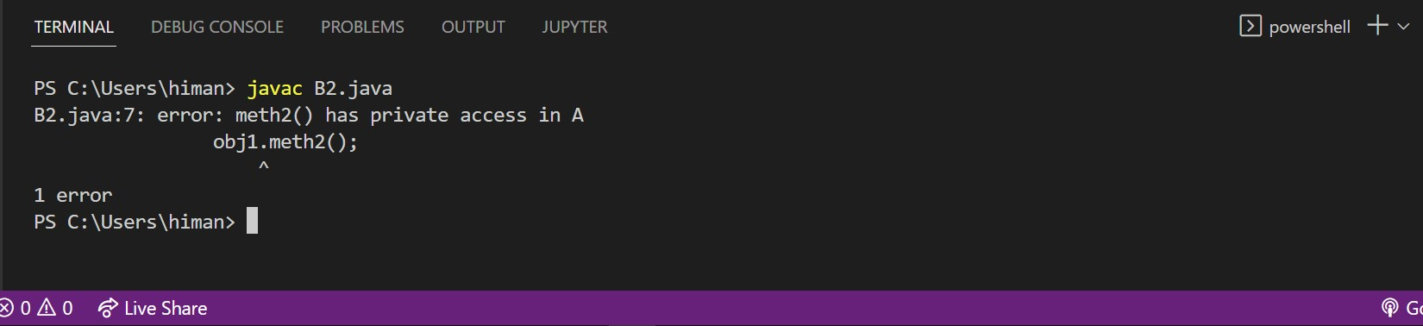

c)

**package** Q;

**import** p.A;

**public** **class** B3{

**public** **static** **void** main(String args[]){

A obj1 = **new** A();

obj1.meth3();

}

}

Output

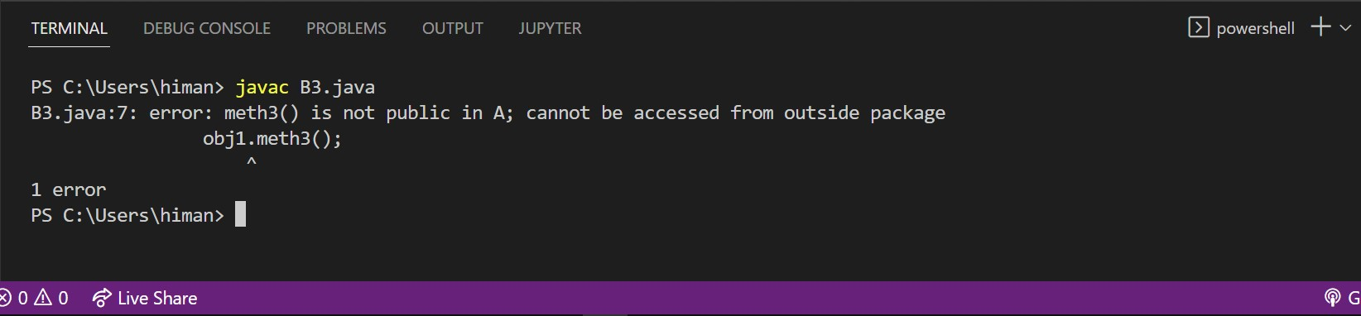

d)

**package** Q;

**import** p.A;

**public** **class** B4{

**public** **static** **void** main(String args[]){

A obj1 = **new** A();

obj1.meth4();

}

}

Output

